Ecumenical conversation group
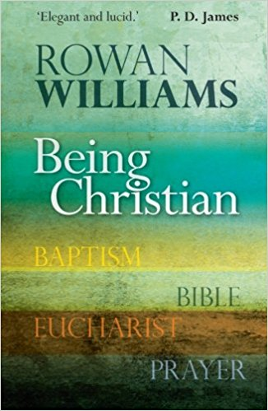
Strinda kirke autumn 2017

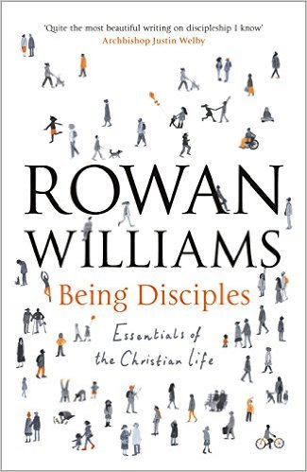

Ecumenical conversation group
Strinda kirke autumn 2017

Ecumenical conversation group
Strinda kirke autumn 2017

Rowan Williams former archbishop of Canterbury is an outstanding theological writer. He explains the essential components of the Christian faith and invites us to explore what it means to be a disciple today.
In the group we will share experiences and insights – faith and doubt. Listening to each other, we will expand our own faith and be encouraged to live as disciples in our daily life.
We think students will benefit and contribute much to the group. The group is of course open for everyone who wants to explore Christian faith.
We will meet the following Wednesdays from 19.30 – 21.30: 30th of August, 13th of September, 27th of September, 11th of October, 25th of October, 8th of November, 22nd of November and 6th of December. We will eat supper and discuss one chapter each time. You’re welcome even if you are unable to participate at every meeting.
Strinda kirke is open every Wednesday from 17.30; meditative music is played between 18.00 and 19.00, followed by a simple communion service 19.00 -19.30. Strinda kirke belongs to the Church of Norway.
You will find Strinda kirke (Brøsetvegen 147) near Moholt studentby; a large white church building.

Questions or registration chaplain Børre Rindal br473@kirken.no
Rowan Williams former archbishop of Canterbury is an outstanding theological writer. He explains the essential components of the Christian faith and invites us to explore what it means to be a disciple today.
In the group we will share experiences and insights – faith and doubt. Listening to each other, we will expand our own faith and be encouraged to live as disciples in our daily life.
We think students will benefit and contribute much to the group. The group is of course open for everyone who wants to explore Christian faith.
We will meet the following Wednesdays from 19.30 – 21.30: 30th of August, 13th of September, 27th of September, 11th of October, 25th of October, 8th of November, 22nd of November and 6th of December. We will eat supper and discuss one chapter each time. You’re welcome even if you are unable to participate at every meeting.
Strinda kirke is open every Wednesday from 17.30; meditative music is played between 18.00 and 19.00, followed by a simple communion service 19.00 -19.30. Strinda kirke belongs to the Church of Norway.
You will find Strinda kirke (Brøsetvegen 147) near Moholt studentby; a large white church building.

Questions or registration chaplain Børre Rindal br473@kirken.no

Rowan Williams former archbishop of Canterbury is an outstanding theological writer. He explains the essential components of the Christian faith and invites us to explore what it means to be a disciple today.
In the group we will share experiences and insights – faith and doubt. Listening to each other, we will expand our own faith and be encouraged to live as disciples in our daily life.
We think students will benefit and contribute much to the group. The group is of course open for everyone who wants to explore Christian faith.
We will meet the following Wednesdays from 19.30 – 21.30: 30th of August, 13th of September, 27th of September, 11th of October, 25th of October, 8th of November, 22nd of November and 6th of December. We will eat supper and discuss one chapter each time. You’re welcome even if you are unable to participate at every meeting.
Strinda kirke is open every Wednesday from 17.30; meditative music is played between 18.00 and 19.00, followed by a simple communion service 19.00 -19.30. Strinda kirke belongs to the Church of Norway.
You will find Strinda kirke (Brøsetvegen 147) near Moholt studentby; a large white church building.

Questions or registration chaplain Børre Rindal br473@kirken.no

